

Fathom One ROV Assembly Instructions

10/31/17

CPU ASSEMBLY

Materials Required

1. 4x #4-40 0.25’’ nylon screws
2. 4x #4-40 0.25’’ nylon standoffs
3. 4x #4-40 nylon hex nuts
4. 1x CPU mount
5. 1x Raspberry Pi CPU
6. 1x Fathom Robotics Shield
7. 1x CSI cable
8. 2x 10K ohm NTC Thermistor w/ wire leads
9. 1x 16GB SD card

Tools Required

1. Phillips screwdriver
2. Flat-nosed pliers
3. Small flat head screwdriver

Assembly Instructions

1. Insert flashed SD card into Raspberry Pi CPU
2. Insert CPU mounting screws into Raspberry Pi.
3. Insert .25’’ standoffs under Pi
4. Place mounting plate onto screws
5. Secure mounting plate with 4 hex nuts
6. Install camera ribbon cable
7. Use a small amount of glue to secure ribbon cable into receptacle
8. Install robotics shield using GPIO pins
9. Install thermistors into robotics shield

HULL ASSEMBLY PT 1

Materials Required

1. 9x #6-32 0.75’’ stainless hex head screw
2. 9x #6-32 0.25’’ aluminum threaded standoff
3. 9x 20A custom ESCs
4. 1x 150 PSI pressure transducer
5. LocTite

Tools Required

1. Socket wrench
2. Custom pressure transducer mounting tool

Assembly Instructions

1. Insert a #6-32 hex screw through ESC ring terminal
2. Use a socket wrench to push the screw through the hull screw holes
3. Tighten a .25’’ standoff onto the screw on the outside of the hull, use a small amount of Loctite between the hull and standoff to secure
4. Repeat for all ESCs
5. Mount depth sensor by using custom transducer wrench to screw into plastic mounting boss

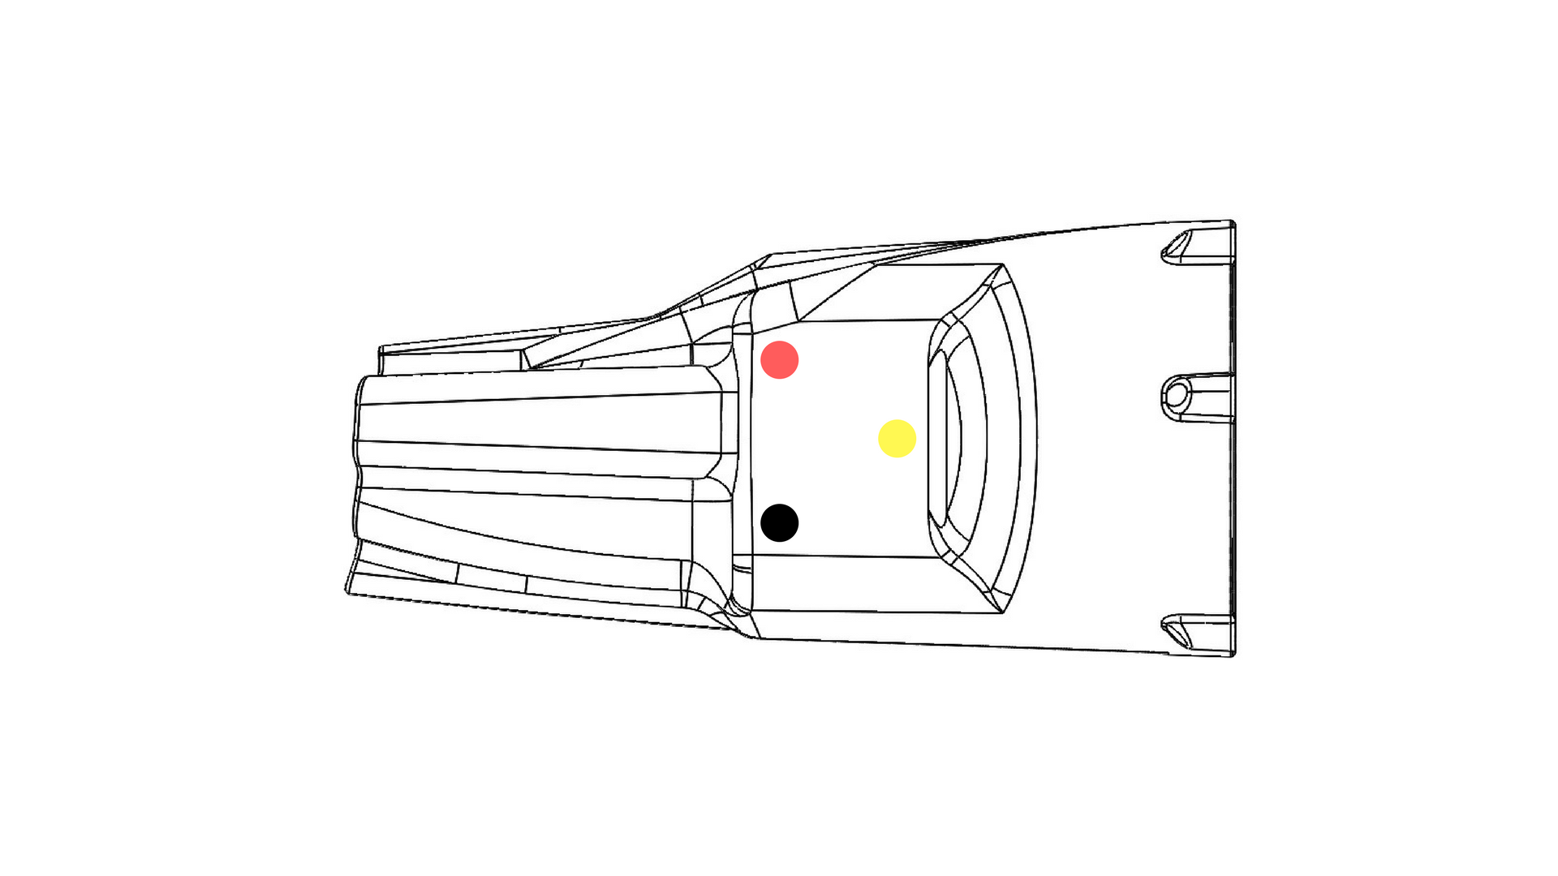

RIGHT SIDE ESC WIRING

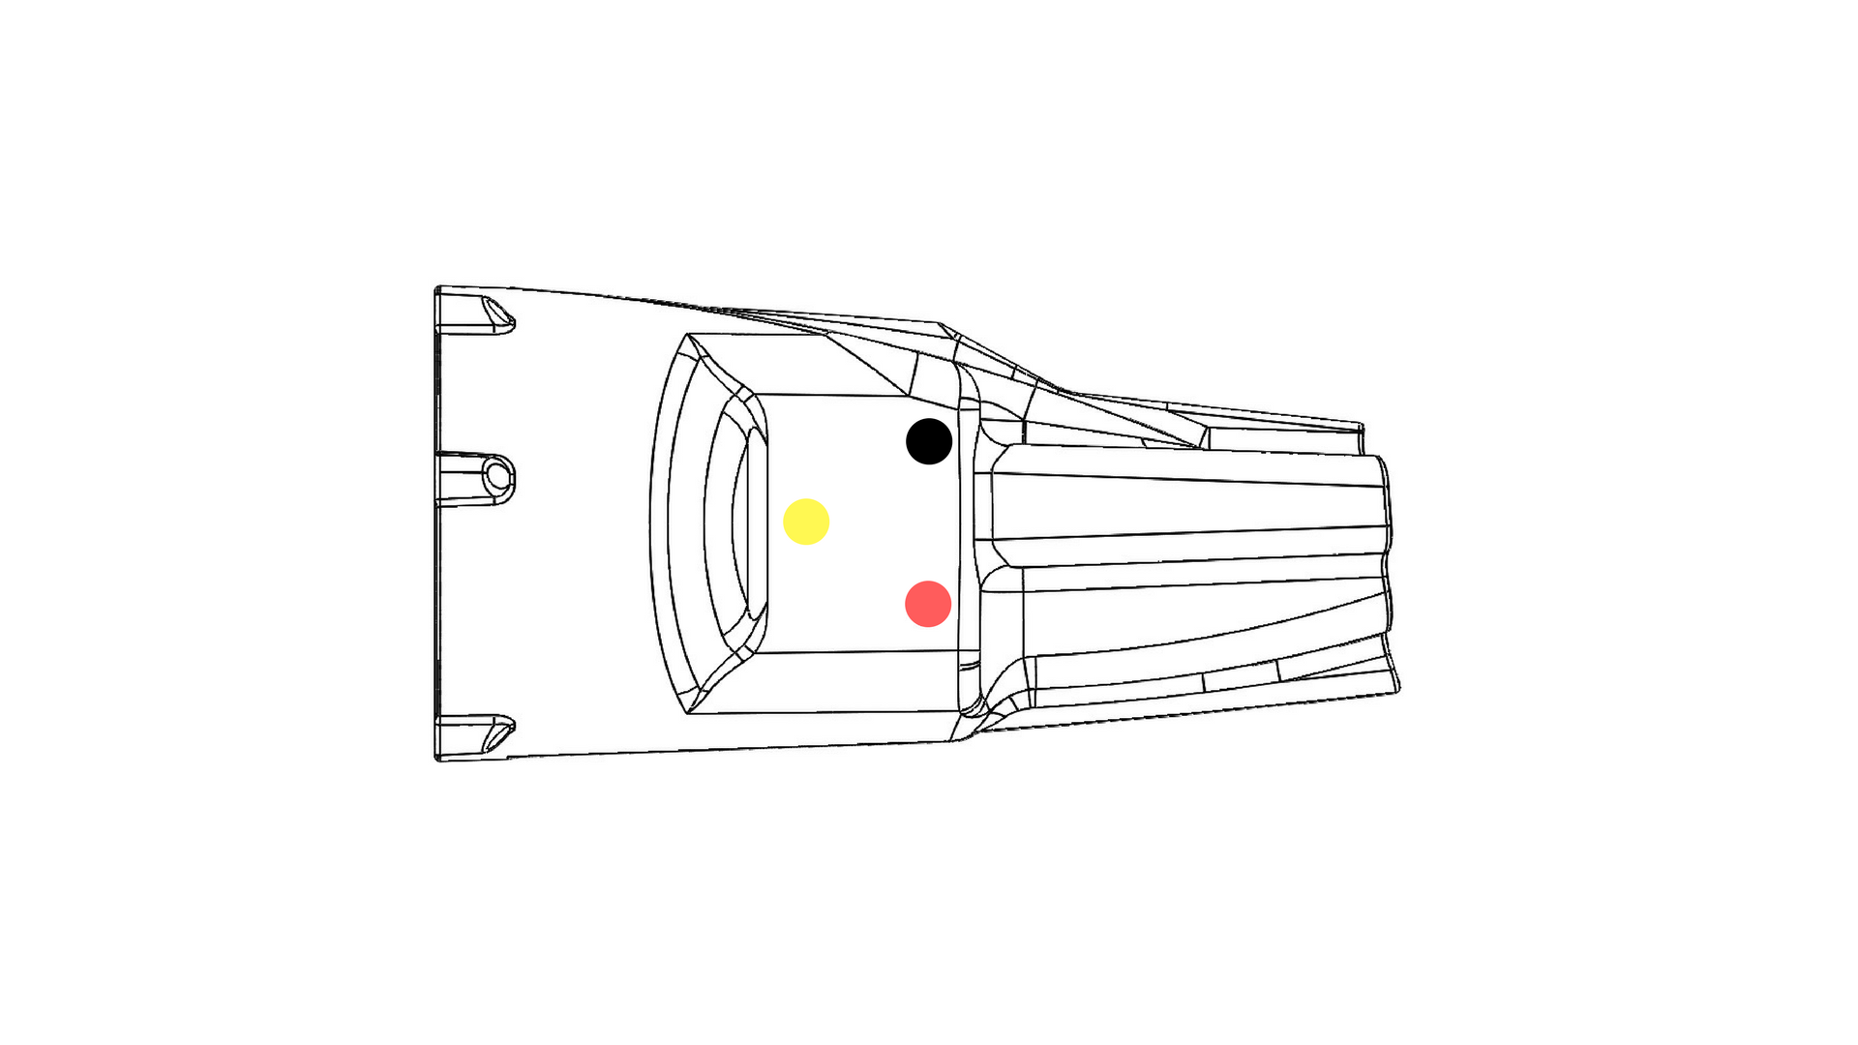

LEFT SIDE ESC WIRING

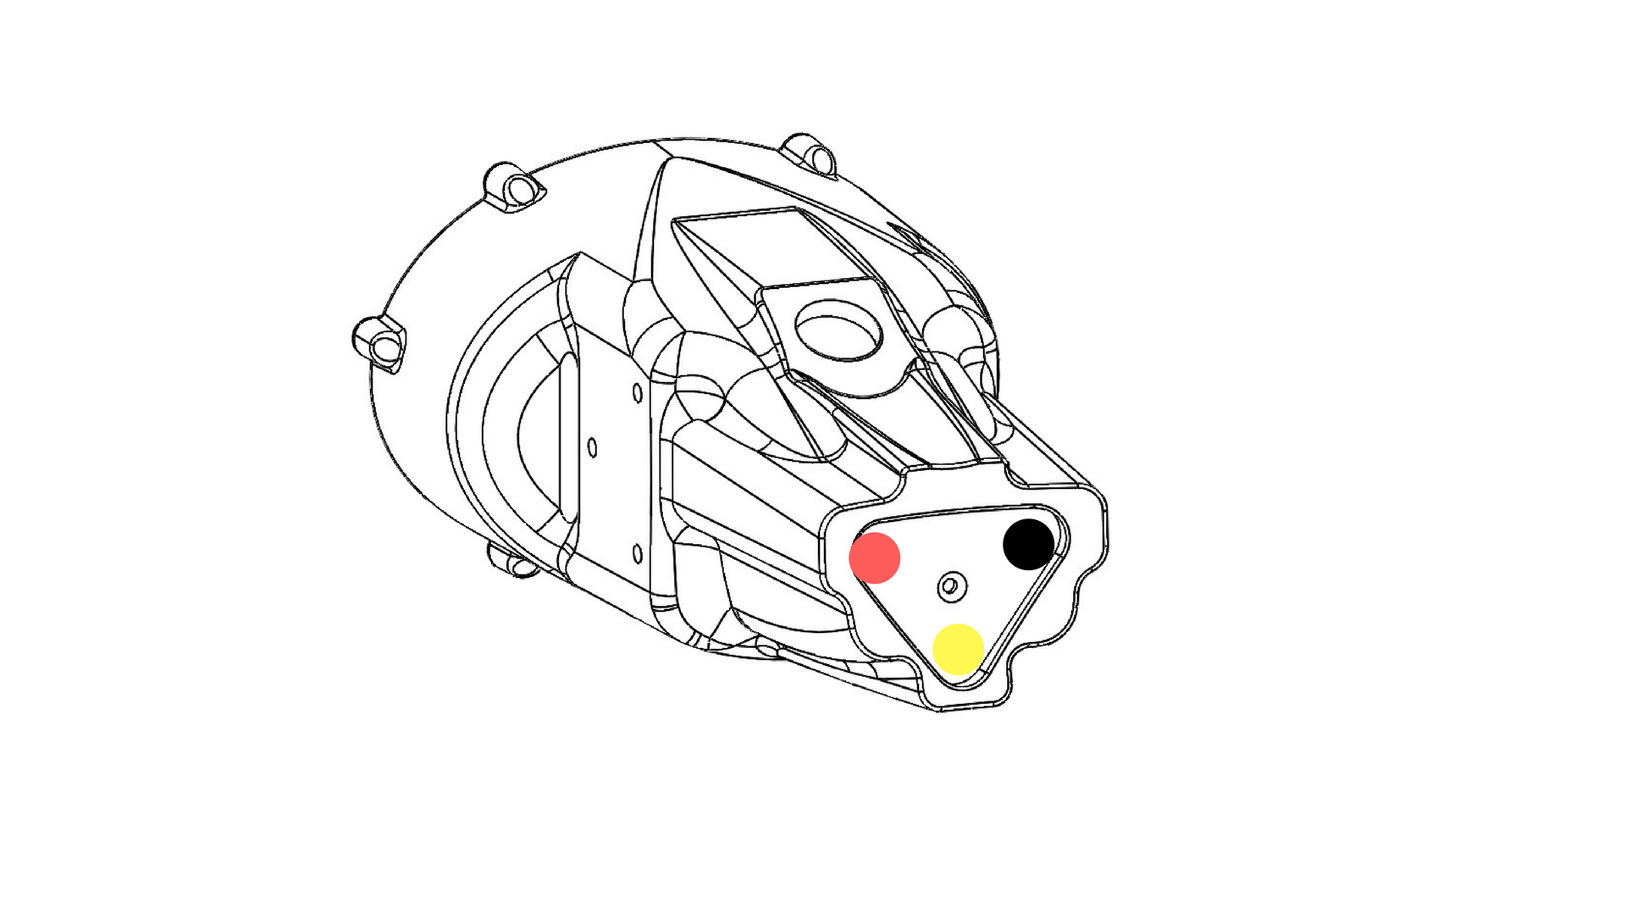

REAR ESC WIRING

HULL ASSEMBLY PT 2

Materials Required

1. 1x female tether interface
2. 1x locking nut

Tools

1. Needle-nosed pliers

Assembly Instructions

1. Thread cable assembly through top tether mounting hole
2. Thread locking nut over the Ethernet plug, and screw onto tether interface

FRONT CAP ASSEMBLY

Materials Required

1. 6x #1 1/8’’ self threading screws
2. 4x #6 1/4’’ self threading screws
3. Solder
4. 15’’ 26 AWG
5. 2x 3W star-type LEDs
6. 1x Raspberry Pi camera module

Tools Required

1. Phillips screwdriver
2. Soldering iron
3. Wire stripper

Assembly Instructions

1. Secure camera onto front mounting plate using 2x #1 1/8’’ self threaded screws
2. Solder 2x 3W LEDs together
3. Mount LEDs onto front plate using 4x #1 1/8’’ self threading screws
4. Screw mounting plate into the front cap using 4x #6 1/4’’ self threading screws

THRUSTER ASSEMBLY

Materials Required

1. 12x #1 0.25’’ self threading screws
2. x3 M3 stainless steel washers
3. x3 M3 stainless steel locking nuts
4. x3 custom 800 KV brushless motors
5. x2 L/T propellers
6. x1 R propeller
7. x3 thruster housing

Tools Required

1. Small phillips screwdriver
2. Small allen wrench
3. M3 socket wrench

Assembly Instructions

1. Screw thruster mounting plate into housing using 4x #1 0.25 self threading screws
2. Place propeller over motor bell, and install a washer and lock nut to hold it in place
3. Place motor bell into mounting plate and lock using 2x set screws

HULL ASSEMBLY PT 3

Materials Required

1. 1x charging interface assembly
2. 1x locking nut
3. 1x 3S balance lead extension

Tools Required

1. Needle-nosed pliers

Assembly Instructions

1. Clip the 3S balance lead extension close to the female plug
2. Solder male-side 3S balance lead extension to female charging plug
3. Thread 3S balance lead and plug assembly through hull charging port
4. Thread the locking nut over the charging cables, and tighten into place

HULL ASSEMBLY PT 4

\*QUALITY RISK AREA\*

Materials Required

1. 1x CPU assembly
2. 1x front cap assembly
3. 1x hull assembly
4. 1x 5200mAh LiPo battery pack
5. 1x steel ballast (2.85’’ x 2.5’’ x 0.25’’)
6. 1x steel ballast (3.64’’ x 2.5’’ x 0.25’’)

Tools Required

1. 1x small flat head screwdriver
2. 1x test tether
3. 1x test router
4. 1x test smart device

Assembly Instructions

1. Connect the Ethernet plug to the Raspberry Pi CPU, and the lights, transducer, ESC signal wires, PoE wires, and MOSFET switching leads to the Robotics Shield.
2. Slide shield/Pi assembly into its mounting slot
3. Connect the ESC power lines and the CSI cable to the Raspberry Pi camera module
4. Connect battery to perform diagnostics
5. Seal off the Raspberry Pi using hot glue between the Pi and the robotics shield
6. Install 506g of steel ballast into ballast mounting brackets

HULL ASSEMBLY PT 5

\*QUALITY RISK AREA\*

Materials Required

1. 624/625 potting foam
2. Mixing cup
3. Mixing stick

Tools Required

1. Potting fixture

Assembly Instructions

1. Mix 2.1oz of each side of the foam potting material into a mixing container, and mix thoroughly.
2. Pour the foam mixture into the tail of the drone through the bottom of the hull
3. Hold the battery in place to ensure the foam doesn’t push it forward into the allotted space for the front cap
4. Let foam set
5. Visually inspect to ensure there are no gaps between the foam and thruster interfaces

HULL ASSEMBLY PT 6

Materials Required

1. 1x front cap o-ring
2. Silicone grease
3. 6x #6 5/8'' high-low self threading screw
4. 1x hull/front cap assembly
5. 1x silica packet
6. Adhesive

Tools Required

1. Phillips screwdriver

Assembly Instructions

1. Place silica packet inside drone hull
2. Use a small amount of adhesive to tack both thermistors onto the left and right sides of the battery
3. Lubricate the front cap o-ring using silicone grease
4. Place o-ring into the front cap open groove
5. Screw the front cap into place using 6x #6 5 / 8’’ self threading screws

HULL ASSEMBLY PT 7

Materials Required

1. Polycarbonate industrial adhesive
2. 1x picatinny rail

Tools Required

1. Rail mounting fixture

Assembly Instructions

1. Place picatinny rail fixture over the drone body
2. Apply adhesive to the picatinny rail piece
3. Firmly press picatinny rail into its corresponding location and let set

THRUSTER ATTACHMENT

Materials Required

1. x9 #6-32 plastic thumb nuts
2. 1x finished hull assembly
3. 3x finished thruster assemblies (2x left handed prop, 1x right handed prop)

Tools Required

N/A

Assembly Instructions

1. Place motor leads over their corresponding thruster mounting posts according to the schematic below
2. Slide thruster housing over thruster mounting posts
3. Secure thruster housing using 3x plastic thumb screws per thruster

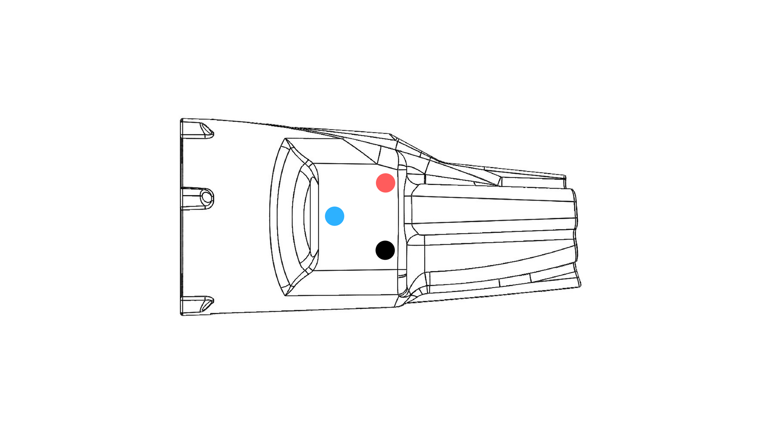

LEFT MOTOR WIRING

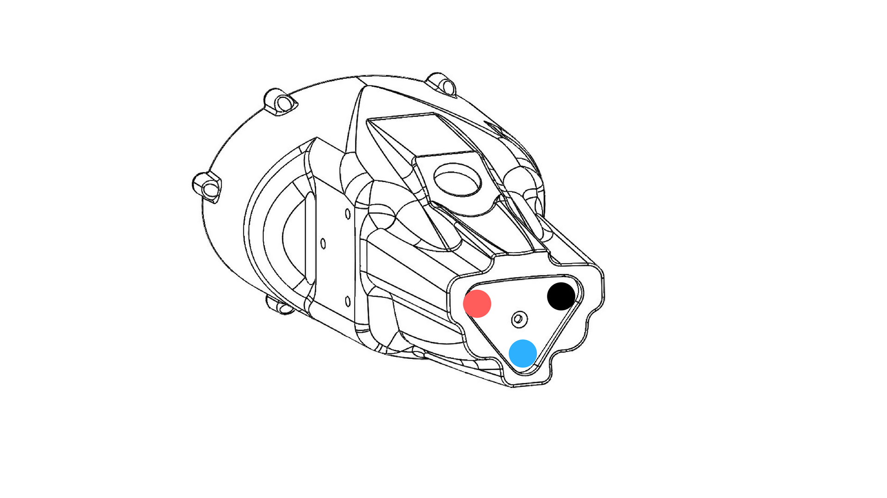

REAR MOTOR WIRING

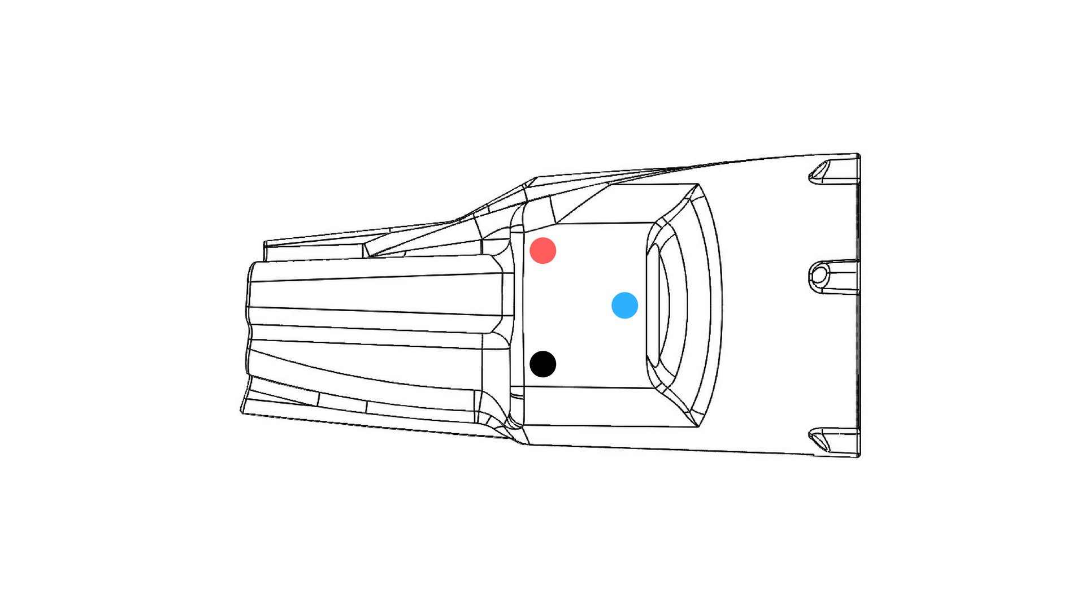

RIGHT MOTOR WIRING

TOPSIDE ASSEMBLY

Materials Required

1. 3x #6 1/4’’ self threading screws
2. 4x #6 5/16’’ self threading screws
3. 1x wireless transmitter top
4. 1x wireless transmitter bottom
5. 1x Hornet Routerboard
6. 1x lock washer
7. 1x antenna hex nut
8. 1x 5dbi antenna
9. 1x IPEX-RSMA(F)1.13-10
10. 1x female tether interface
11. 1x tether locking nut

Tools Required

1. Phillips screwdriver
2. Needle-nosed pliers

Assembly Instructions

1. Place PCBA routerboard into bottom clamshell piece
2. Secure using 3x #6 ¼’’ mounting screws
3. Thread antenna port through top hole
4. Secure using a locking washer and nut
5. Thread female tether cable assembly through bottom hole
6. Thread locking nut over Ethernet jack and screw into place
7. Connect Ethernet jack to routerboard
8. Install antenna
9. Secure top clamshell piece using 4x #6 5/16’’ mounting screws